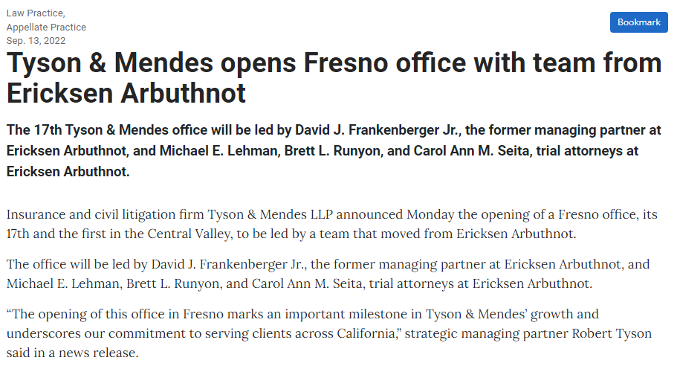
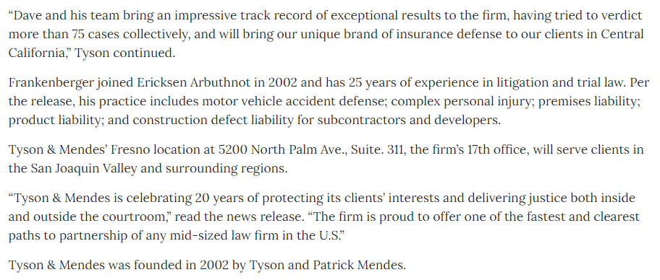

https://www.dailyjournal.com/articles/369063-tyson-mendes-opens-fresno-office-with-team-from-ericksen-arbuthnot

